**Document related to TeamsBot PowerShell Script**

* Copy Zip file to a destination folder.
* Extract the Zip file.
* Open Powershell as Administrator
* Go to the location where powershell script is located i.e. the folder we extracted.
* Run the powershell script
* **It will ask for Appserver as well as Central Config the ipaddress/ Machine name/ localhost name**. Please provide appropriate i**paddress/ Machine name/ localhost**.
* Done

**What power script will do?**

* Creating the directory in inetpub folder
* Creating a new application pool
* Set item property for newly created Application pool
* Creating a new Web Application
* Set item property for newly created Web Application
* Silent install Required application
* Copy binaries to required destination folder
* Create new appsetting.json once **the ipaddress/ Machine name/ localhost name**

is provided

**AppSetting JSON file:**

{"MicrosoftAppId"="";"MicrosoftAppPassword"="";"IPCMURL"= "http://$**AppserverIPAddress**/HEAT/ServiceApi/IPCMService.asmx"; "WorkflowURL"= "http://$**AppserverIPAddress**/HEAT/ServiceApi/WorkflowService.asmx"; "ConfigURL"= "http://$**CentralConfigIPAddress**/CentralConfig/ConfigServiceAPI.asmx"; "RetrieveTenantLogLevel_ws_url"= "http=//$**CentralConfigIPAddress**/CentralConfig/RetrieveTenantLogLevel.ashx"; "EnableCentralLogging"= "false"; "LoggingService_ws_url"= "http://$**AppserverIPAddress**/Heat.Logging.Service/api/LoggingService/HeatServiceManagementLogging"; "ElapsedSecondsToFlushLog"= 60; "ItemSizeToFlushLog"= 1000; "LogSettingCacheTimeoutInMinutes"= 5; "SendLogFileLocation"= "C:\logs"; "WriteLogFileLocation"= "C:\logs"; "SendLogWaitInterval"= 300; "WriteLogWaitInterval"= 300; "EnableLogging"= "true"; "CacheTimeout"= "30"; "CentralConfigApiKey": "" }

If provided **ipaddress/ Machine name/ localhost name** is wrong and need to changed then we can change in folder – inetpub -> TeamsBotService. Inside that find file called “Appsetting.json” replace **the ipaddress/ Machine name/ localhost name.**

**Note:**

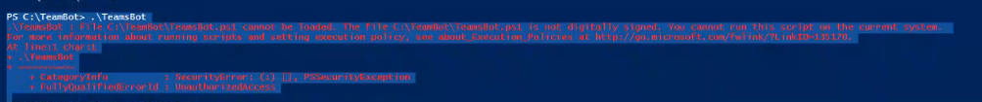

**Please Run execute below command:**

**Run “Get-ExecutionPolicy” -list to know the Execution policy.**

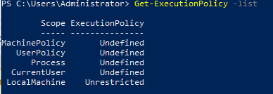

*Note down the value so that it can be used to revert the changes at the end.*

**Set-ExecutionPolicy -ExecutionPolicy Unrestricted -Scope LocalMachine**

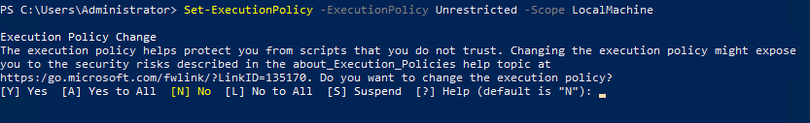

**Type Y and press Enter**

**If you need to revert the Execution policy once the PowerShell TeamsBot PowerShell script is executed successfully. Then follow below command**

**Set-ExecutionPolicy -ExecutionPolicy “PROVIDE PREVIOUS VALUE” -Scope LocalMachine**